PROJECT REPORT
SMARTCART E-Commerce Management System

GROUP MEMBERS:
Areeba Imran 24K-0005
Alishba Zehra 24K-0018
Azan Naveed 24K-5638

Introduction
The rapid growth of online shopping has increased the demand for efficient e-commerce systems capable of managing products, customers, and transactions seamlessly. SmartCart addresses this need by providing a smart e-commerce platform that combines a structured database with an interactive web interface.
The primary objective of this project is to design and implement a complete database-driven application that reflects real-world business operations. SmartCart not only allows users to shop online but also provides administrative control for inventory and sales management.
Unlike simple static systems, SmartCart uses Oracle XE for enterprise-level database operations and integrates advanced concepts such as triggers, views, and transactions. This makes it a comprehensive academic project that bridges theoretical database knowledge with practical application development.

Problem Statement
Traditional shopping systems often suffer from poor inventory management, inconsistent customer records, and inefficient order handling. Many small-scale systems also lack automation in stock updates and transaction safety.
The challenge was to design a scalable and normalized database-backed e-commerce system that could efficiently manage large datasets while ensuring data integrity and operational reliability.
SmartCart solves these issues by implementing a relational database structure with automated processes, optimized queries, and a user-centered interface.

Objectives
The main objectives of SmartCart are:
- To develop a complete e-commerce management system
- To design a normalized relational database up to BCNF
- To implement efficient SQL queries for data retrieval and analysis
- To provide customer-side shopping features such as cart and wishlist
- To provide admin-side inventory and product management
- To ensure transactional consistency and automated stock updates
- To integrate backend logic with a responsive frontend interface

Technologies Used
Layer | Technology
Database | Oracle XE
Backend | Python, Flask
Frontend | Bootstrap 5
Templating | Jinja2
Database Connector | cx Oracle

These technologies were chosen for their compatibility, scalability, and ability to support enterprise-level database operations.

System Users
Customer
Customers can:
- Browse products
- Search for products dynamically
- Add products to cart
- Add products to wishlist
- Place orders
- View order history

Administrator
Administrators can:
- Add new products
- Delete existing products
- Manage stock levels
- View inventory reports
- Monitor customer orders

Database Design
The SmartCart database consists of the following entities:
- Users
- Categories
- Products
- Orders
- OrderItems
- Cart
- Wishlist
- Payments
Each entity is connected through primary and foreign key relationships to ensure referential integrity.

Normalization
The database was normalized up to Boyce-Codd Normal Form (BCNF).
Users Table
Attributes:
user_id, name, email, password, role, created_at
Functional Dependencies:
- user_id → name, email, password, role, created_at
- email → user_id
Normalization:
- 1NF: Atomic values only
- 2NF: No partial dependency
- 3NF: No transitive dependency
- BCNF: Every determinant is a candidate key

Categories Table
Attributes:
category_id, category_name
Functional Dependency:
- category_id → category_name
Normalized to BCNF.

Products Table
Attributes:
product_id, category_id, name, price, stock, description
Functional Dependencies:
- product_id → category_id, name, price, stock, description
Category details are separated into Categories to remove transitive dependency.
Normalized to BCNF.

Orders Table
Attributes:
order_id, user_id, order_date, total_amount, status
Functional Dependency:
- order_id → user_id, order_date, total_amount, status
Normalized to BCNF.

OrderItems Table
Attributes:
item_id, order_id, product_id, quantity, unit_price
Functional Dependency:
- item_id → order_id, product_id, quantity, unit_price
Normalized to BCNF.

Cart Table
Attributes:
cart_id, user_id, product_id, quantity
Normalized to BCNF.

Wishlist Table
Attributes:
wishlist_id, user_id, product_id
Normalized to BCNF.

Payments Table
Attributes:
payment_id, order_id, amount, payment_date, method
Normalized to BCNF.

Advanced Database Features
Views
Two views were created:
- CustomerOrderView — provides customer order summaries
- AdminInventoryView — provides admin inventory overview
These simplify reporting and improve query efficiency.

Trigger
A trigger named update_stock_trigger automatically deducts stock whenever a new order item is inserted.
This ensures inventory remains updated without manual intervention.

Sequences
Sequences are used for automatic primary key generation across all tables.
This guarantees uniqueness and supports scalability.

Transactions
COMMIT and ROLLBACK mechanisms ensure consistency during order placement.
This protects the system from partial updates in case of failure.

System Implementation
The backend was developed using Flask routes for product display, cart management, order placement, and admin operations.
The frontend uses Bootstrap 5 templates for responsive design and improved user experience.
Oracle XE stores and manages all relational data.

Testing and Results
The system was tested with:
- 50+ products
- 20+ orders
- 50+ order items
- 20+ cart entries
- 80+ wishlist records
- 220+ payment records
The system performed successfully with large-scale sample data, demonstrating scalability and reliability.

Challenges Faced
- Managing foreign key relationships across multiple entities
- Ensuring stock updates occur automatically
- Handling transactions safely
- Integrating Oracle XE with Flask
- Maintaining database normalization while scaling data volume
These challenges were resolved through structured schema design and proper testing.
ER Diagram
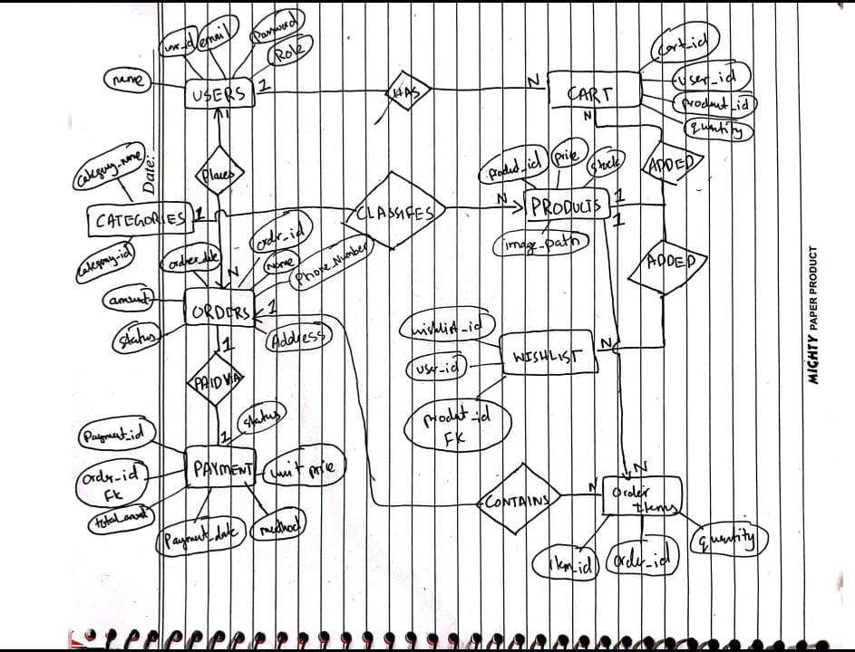

Logical View
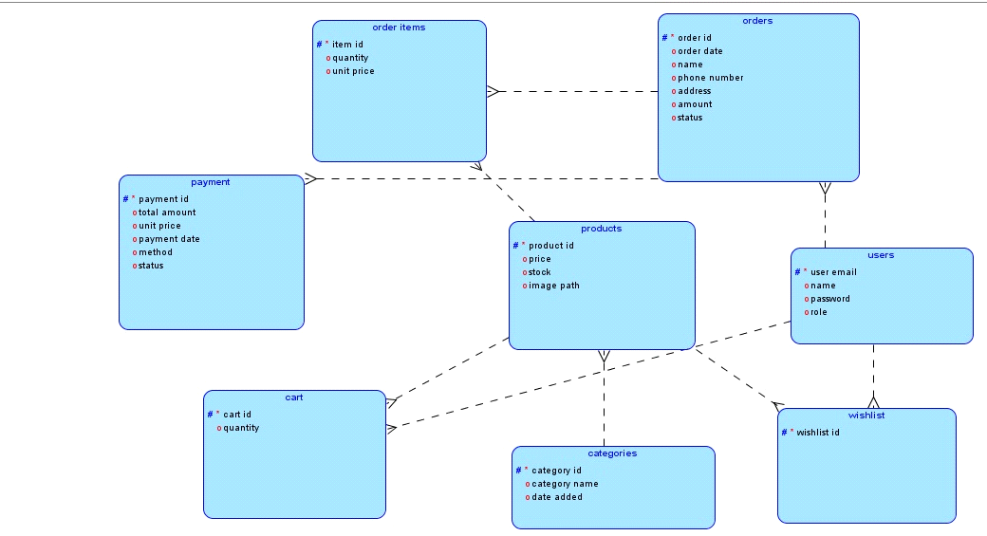

Relational View
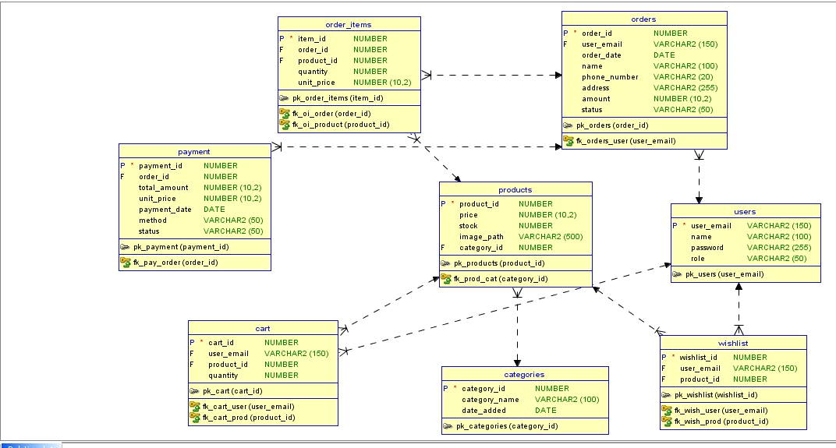

Conclusion
SmartCart successfully demonstrates the design and implementation of a complete database-driven e-commerce management system. The project integrates normalized relational design, advanced SQL operations, automation features, and web-based interaction.
By combining Oracle XE with Flask and Bootstrap, the project provides a practical solution that reflects real-world e-commerce workflows while fulfilling academic objectives.
The system is scalable, reliable, and structured according to professional database standards.

Future Enhancements
Possible future improvements include:
- Online payment gateway integration
- Delivery tracking system
- Customer reviews and ratings
- AI-based product recommendations
- Mobile application support
These features would further enhance usability and commercial viability.

